PLAYER REGISTRATION FORM
SEASON 2021-2022 v1.1

Player Information
Full Name: _______________________________________________________ FAN No.: ____________________
Address: _____________________________________________________________________________________
Phone: ____________________________________ Email: _____________________________________________
Medical Conditions: ____________________________________________________________________________
Date of Birth: _____________________________ Place of Birth: ________________________________________
Nationality: __________________________ Maiden / Previous Name: __________________________________
Please provide an electronic close-up photo of your full head and upper shoulders (sending this to your Manager via Whatsapp). The photo must contain no other people or objects and be in clear contrast to the background.
Club Information
Club Registering For: __________________________________________________________________________
Have you ever played or registered for a club outside of England? | Yes | No
If Yes, please provide details: ____________________________________________________________________
Parental Information
This part of the form MUST be completed if the player is under 18 years old
Parent’s Name: ____________________________________________ Date of Birth: ________________________
Phone: ____________________________________ Email: _____________________________________________
Address: _____________________________________________________________________________________
Signatures
Player
I hereby agree to comply with the rules and RESPECT values of the FA and AALGFC at all times.
Signature: ______________________________________________________ Date: ________________________
Parent (only required if player U18)
I hereby give permission for my child to participate with the FA and play for AALGFC.
Signature: ______________________________________________________ Date: ________________________
Data Verified & ID Checked By: ______________________________ (ID can be Passport, Birth Certificate or Driving License)
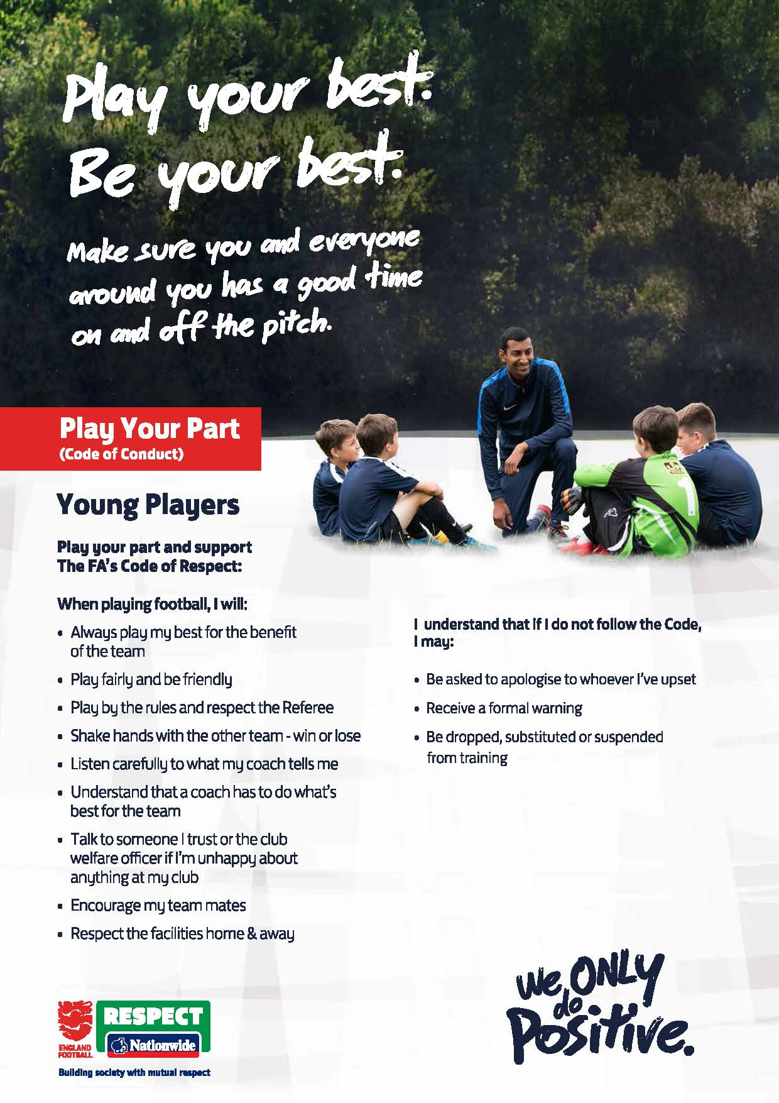

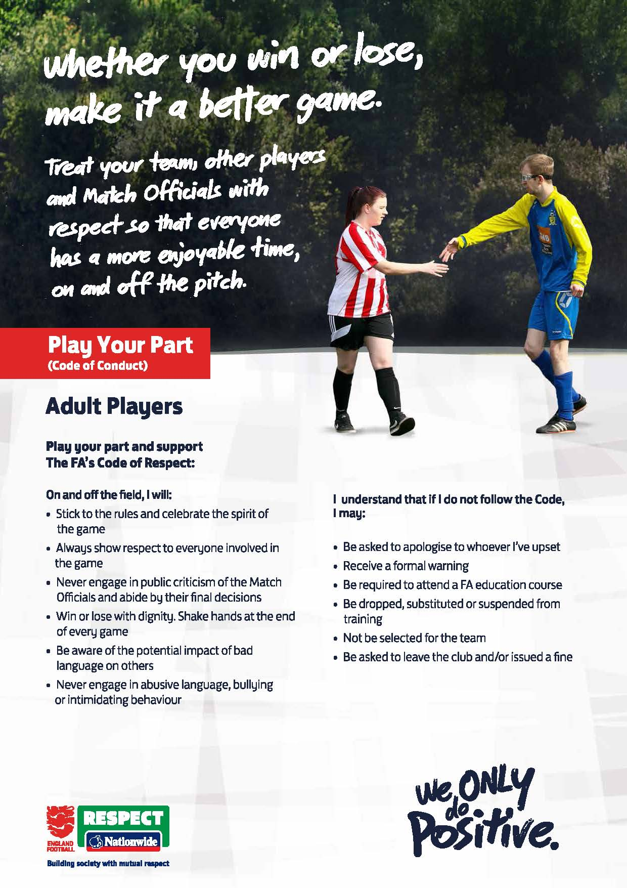

Player Signature: _______________________

Date: _______________________

Do you give permission for AALGFC to take photographs / videos of you for fundraising and publicity?  This may include (but is not limited to) printed and online publicity, social media, press releases and funding applications. | Yes  No
How did you find out about AALGFC? ____________________________________

